Logic Gate Worksheet
X | Y
- A Logic circuit has two inputs being X and Y
fill in all the possible combinations.

- Find the output for the following:
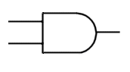
0

1

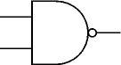
1

0

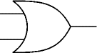
1

0

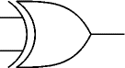
1

0

- The figure below shows a logic circuit and its incomplete truth table. Complete the below truth table.

A | B | C | Q
0 | 0
0 | 1
1 | 0
1 | 1
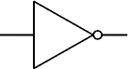
B
A
C
Q

- The figure below shows a logic circuit and its incomplete truth table. Complete its truth table.

B
A
C
Q
D
A | B | C | D | Q
0 | 0
0 | 1
1 | 0
1 | 1

- The figure below shows a logic circuit and its incomplete truth table. Complete the below truth table.
Q
A
B
C

D
A | B | C | D | Q
0
0
1
1

- The figure below shows a logic circuit and its incomplete truth table. Complete the below truth table.
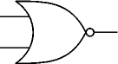
C
B
A
Q
D
A | B | C | D | Q
 | 0
 | 1
 | 0
 | 1

- For the logic circuit below complete the truth table.
A | B |  |  | D
0 | 0
0 | 1
1 | 0
1 | 1
A
D

B

Answers:
1.
X | Y
1 | 0
1 | 1
0 | 0
0 | 1

2. a) 0 b) 1 c) 1 d) 1

3
A | B | C | Q
0 | 0 | 0 | 1
0 | 1 | 1 | 0
1 | 0 | 1 | 0
1 | 1 | 1 | 0

4.
A | B | C | D | Q
0 | 0 | 0 | 0 | 0
0 | 1 | 1 | 1 | 1
1 | 0 | 1 | 0 | 0
1 | 1 | 1 | 1 | 1

5.
A | B | C | D | Q
0 | 0 | 0 | 1 | 1
0 | 1 | 1 | 0 | 1
1 | 0 | 1 | 1 | 0
1 | 1 | 1 | 0 | 1

6.
A | B | C | D | Q
0 | 0 | 1 | 1 | 0
0 | 1 | 0 | 0 | 1
1 | 0 | 0 | 1 | 1
1 | 1 | 0 | 0 | 1

7.
A | B |  |  | D
0 | 0 |  |  | 0
0 | 1 |  |  | 1
1 | 0 |  |  | 1
1 | 1 |  |  | 1

